NOTIFICATION
1. | Notifying Member: CHINA  If applicable, name of local government involved:
2. | Agency responsible: National Health Commission of the People's Republic of China
3. | Products covered (provide tariff item number(s) as specified in national schedules deposited with the WTO; ICS numbers should be provided in addition, where applicable): Food additive Calcium ascorbate
4. | Regions or countries likely to be affected, to the extent relevant or practicable:  [X] All trading partners  [ ] Specific regions or countries:
5. | Title of the notified document: National Food Safety Standard of the P.R.C.: Food additive Calcium Ascorbate No. 1 Amendment. Language(s): Chinese. Number of pages: 1  https://members.wto.org/crnattachments/2022/SPS/CHN/22_6644_00_x.pdf
6. | Description of content: 2.3 Structural formula  Changes "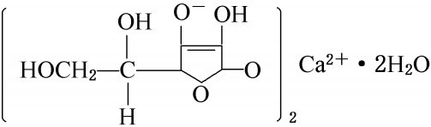" to "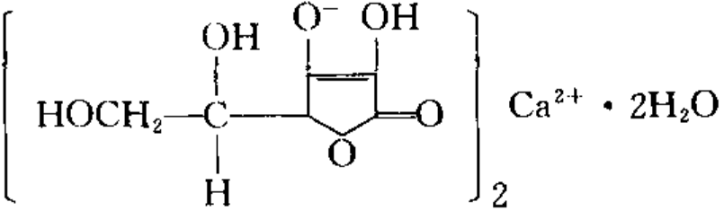".
7. | Objective and rationale: [X] food safety, [ ] animal health, [ ] plant protection, [ ] protect humans from animal/plant pest or disease, [ ] protect territory from other damage from pests.
8. | Is there a relevant international standard? If so, identify the standard:  [ ] Codex Alimentarius Commission (e.g. title or serial number of Codex standard or related text):  [ ] World Organization for Animal Health (OIE) (e.g. Terrestrial or Aquatic Animal Health Code, chapter number):  [ ] International Plant Protection Convention (e.g. ISPM number):  [X] None  Does this proposed regulation conform to the relevant international standard?  [ ] Yes [ ] No  If no, describe, whenever possible, how and why it deviates from the international standard:
9. | Other relevant documents and language(s) in which these are available:
10. | Proposed date of adoption (dd/mm/yy): To be determined.  Proposed date of publication (dd/mm/yy): To be determined.
11. | Proposed date of entry into force: [ ] Six months from date of publication, and/or (dd/mm/yy): To be determined.  [ ] Trade facilitating measure
12. | Final date for comments: [X] Sixty days from the date of circulation of the notification and/or (dd/mm/yy): 28 November 2022  Agency or authority designated to handle comments: [ ] National Notification Authority, [X] National Enquiry Point. Address, fax number and e-mail address (if available) of other body:  WTO/SPS National Notification and Enquiry Center of the People's Republic of China  Tel:+(86 10) 5795 4645/5795 4642  E-mail: sps@customs.gov.cn
13. | Text(s) available from: [ ] National Notification Authority, [X] National Enquiry Point. Address, fax number and e-mail address (if available) of other body:  WTO/SPS National Notification and Enquiry Center of the People's Republic of China  Tel: +(86 10) 5795 4645/5795 4642  E-mail: sps@customs.gov.cn

